Updated September 2024

Our fees get reviewed termly

Alrewas Village Hall, Wellfield Rd, Alrewas DE13 7HB

Tel: 07890 530616

“

Learning Through Play in a Nurturing and

Empowering Environment

.

”

Prospectus



Stepping Stones Pre-School Play and Learn, is situated in Alrewas Village Hall on Wellfield Road. The Pre School is a registered charity (No. 1026412) and operates as a not for profit organisation. We are affiliated with the Early Years Alliance (No. 33170) and are fully inspected and registered with OFSTED (No. 218625).

We are registered to take up to 38 children and children are supervised by experienced staff. We accept children between the ages of 18 months and 5 years. Sessions are a combination of free play, allowing each child to socialise and gain confidence during the course of play, as well as structured/supervised activities to maximise their learning experiences. We place importance on the physical and mental health and well being of the children in our care. For older children (in the academic year before they start in Reception class), there is a more structured and progressive approach to prepare them for starting school.

We operate a ‘Key Worker’ system for all children by allocating a member of staff to each child. They ensure that each child reaches their potential whilst working at their own pace. They keep the parents informed about their child’s progress and development throughout their time at Stepping Stones. Parents are always welcome to talk to their child’s Key Worker, but we politely request that an appointment is made. This is so we can maintain the correct staff : children ratio during the appointment.

We are a separate organisation from All Saints Primary School, but we have strong links with their Early Years Unit. We also have good links with other local feeder schools. This helps our older children feel at ease and supported during their transition to Primary School.

Stepping Stones gets involved in many community activities and events, such as Alrewas Show, Scouts Bonfire night, Remembrance Sunday, Fayres, and Church events.

The Pre-School is run by paid staff and by a group of volunteers elected onto a Management Committee. As we are a ‘not for profit charity run business’ we can offer low-cost affordable childcare places. We rely on the income from the fees that parents pay and fund-raising events throughout the year to cover all outgoing costs.

|  |
| --- |
| OFSTED  We were inspected by OFSTED in September 2019. We were very pleased to have been rated Good.  Some of the key findings from the Inspection Report are that we:   * plan a broad and exciting curriculum to support the best progress of the children in our care * teach the importance of a healthy body and healthy mind * ignite children’s thirst for learning * enable children to feel confident and secure; and be inquisitive, respectful, motivated and independent * have welcoming and well qualified staff with high expectations and strong parent / staff partnerships     If you would like to read our report, it can be found on: https://reports.ofsted.gov.uk/provider/16/218625 |

# Admissions Procedure

If you wish to register your child with us here at Stepping Stones, the Registration Pack can be handed / emailed to you. This includes all the paperwork you need to complete. This should be returned prior to, or at, your child’s first session. You should also

bring in your child’s original FULL UK birth certificate as we need to see proof of identity. There is a one-off registration fee of £30 that is payable at the start. Please note that once your child has a place confirmed, you will be charged for that place whether your child attends or not. There can be no refunds for non attendance.

# Starting With Us

A child who is unsettled or unhappy will not be able to play or learn properly, so it is important for parents and staff to work together to help him/her to feel confident and secure in the group. Your child’s Key Worker will help your child to settle in by keeping a watchful eye on him/her particularly during the first few weeks. We are a fully inclusive setting and can cater for a range of dietary requirements – just let us know on the registration forms.

# 

Aims and Curriculum

We aim to provide a high quality, secure and stimulating environment inwhich all children can play and learn. We follow the Early YearsFoundation Stage document, and through our planning address all seven areas of learning detailed in it. We also intrinsically teach British Values through our planning. For more information about British Values, look at https://www.pacey.org.uk/news-and-views/pacey-blog/2015/september-2015/fundamental-british-values-in-the-early-years/

THE EYFS

The seven main areas of the EYFS are:

* Personal, Social and Emotional Development
* Physical Development
* Communication and Language
* Literacy
* Mathematics
* Understanding The World
* Expressive Arts and Design

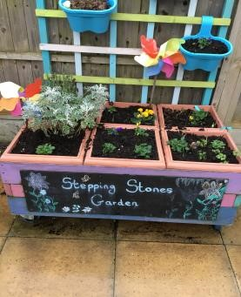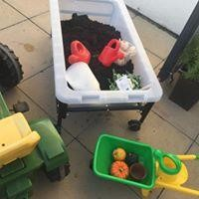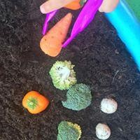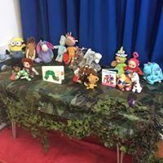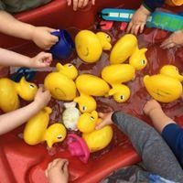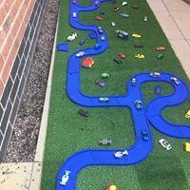

## Staffing

The team consists of experienced and highly qualified members of staff. Equally importantly – we are all mums! All staff have current Enhanced DBS and Child Barred List checks, and regular checks are undertaken to ensure that they continue to be suitable to work with children. Our staff team is committed to completing on-going training including paediatric first aid, safeguarding, food hygiene and other relevant courses.

## Safeguarding Children: Safeguarding Statement

Stepping Stones believes that every child is entitled to a safe and happy environment. All adults associated with Stepping Stonesare committed to this statement. Anyone using Stepping Stones will also accept these principles and should anyone have any concerns the advice of professional agencies will be sought.

|  |  |  |  |  |  |
| --- | --- | --- | --- | --- | --- |
| Timings  We are open during Staffordshire County Council term time, except for occasional staff training days, and depending on the interest we run a Summer Holiday Club during the first three or four weeks of the school summer holidays. Session times are as follows: | | | | | |
|  |  | Morning session | Lunch | Afternoon session | is |
| Monday | 9.00 – 11.30 | 11.30-12.30 | 12.30 - 3.00 |
| Tuesday | 9.00-11.30 | 11.30-12.30 | 12.30 - 3.00 |
| Wednesday | 9.00 – 11.30 | 11.30-12.30 | 12.30 - 3.00 |
| Thursday | 9.00 – 11.30 | 11.30-12.30 | 12.30 - 3.00 |
| Friday | 9.00 – 11.30 | 11.30-12.30 | 12.30 - 3.00 |
| Collection Times  When picking up children, please arrive at 11.30 for pick up after a morning session and 3.00pm for pick up after an afternoon session. If picking up after lunch club, then arrive at 12.30pm.    Extra Sessions  If a child does not attend their normal session, their place can be taken by another child doing an extra session. These are allocated on a “first come first served” basis, extra sessions can be booked if spaces are available. To check availability for extra places on selected days, please give us a call. For regular extra sessions, please speak to the Manager. Sessions cannot be swapped for different sessions/days.    Lunch Time Sessions  Lunch club is available every day from 11.30am. You need to provide a named packed lunch for your child. The cost for the session  £4.00 per child, this will be added to your half termly fees. Lunch sessions that are not pre-booked must be paid for on the day. | | | |

## Clothing

It is best to send your child to a session in clothes that are easily washable and not too new, as paints and glue are readily available!

Simple clothing enables the children to be more independent when going to the toilet or when getting ready to go home.

All children should bring a named change of clothes with them in a clearly named bag. Children who are still in nappies must also bring with them fresh nappies, baby wipes and nappy sacks. We respectfully request that, unless your child is potty training, you pack nappies rather than pull ups. If your child is potty training, please speak to your child’s key worker to discuss their particular requirements. Please regularly check and restock your child’s bag.

Please dress your child in appropriate clothes dependent on the weather i.e. sun hats in summer and hats and coats in winter as we aim to get the children outside as much as possible. We also ask that each child brings in their own named sun cream in the summer months –we will re-apply it after lunch when needed.

## Drinks/snacks

During each session we will provide a drink of milk or water and a snack. A range of snacks is provided throughout the week – fresh fruit, crackers, toast, cheese, biscuits as well as themed food (for example Chinese food during Chinese New Year). If your child has dietary requirements, allergies or food intolerances, please let us know and we can ensure we have something suitable for them to eat. We also ask parents to provide a drink from home in a named bottle, and a packed lunch if they are staying for lunch club.

Fees (effective September 2024)

|  |  |
| --- | --- |
| Each child | £15.00 (per session) |
| Lunch Session | £4.00 |
| Full Day rate | £34.00 |
| Registration fee | £30.00 (one off payment- non refundable) |
| Late payment fee | £10.00 |
| Termly fee (Consumables and resources) | £20.00 |

Fees are payable IN ADVANCE of each half term. Fee invoices are sent out via email (or paper on request) a month before the start of the half term and must be paid in advance of the child’s attendance that half term. A deadline for payment will be on the invoice.

Payment methods:

* Cheques - made payable to ‘Stepping Stones’. Parents will be required to pay any fees incurred by Stepping Stones for returned cheques
* Cash - please send cash in a named envelope. If paying by cash, it is the parent’s responsibility to get a receipt.
* Online banking – the fees invoice will give details of account to pay fees into, please use your child’s name as the reference.
* Card payments – we have a card reader for quick and easy payments.
* We can personalise a payment plan to suit your financial circumstances.
* Tax free childcare scheme (replaces childcare voucher scheme).

We also accept funded placements – 18 months, 2, 3 and 4 year old funding, childcare vouchers and tax free childcare.

Funding commences the term after they have turned two/three years old.

Funding must be taken as full days, please speak to the manager for more information.

Please note: one month’s written / emailed notice is required for cancelling a place at Stepping Stones. Should you not wish for

your child to attend during their one month notice period, one full month’s payment will still be required.

### Children with additional needs

At Stepping Stones, we believe that every child develops in their own time and at their own pace. However, should you have any concerns about your child’s development, your child’s Key Worker will be happy to talk to you about it.

### Off to School

This is a group for children who are in their final academic year before starting in Reception. This group focuses on teaching the skills, attitudes, concepts and independence necessary for a successful transition to Primary School. This is when children learn to write their name, start to learn the phonics skills necessary for reading and writing and develop their problem solving skills. Children’s confidence, personal, social, emotional, language and self-help skills are developed through stimulating activities that encourage children to learn individually and in groups through play. We advocate transition visits to primary school and communicate with Reception teachers to make the process as smooth as possible for our children.

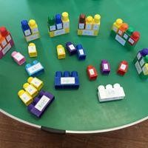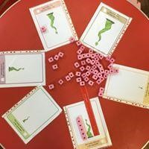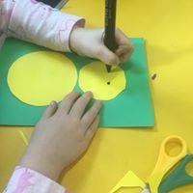

# Trips and Visitors

From time to time, we take the children out on walks around the village to enrich their learning in the setting. Places we have been to include All Saints Primary School, All Saints Church and on a bear hunt to the park, some children have represented us at events at the National Memorial Arboretum. You will be informed and permission will be sought prior to the visit.

We actively encourage visitors to come into the setting to talk to the children. We have recently enjoyed visits from a local farmer, our village PCSO, lambs and a puppy! Please be assured that all these activities are suitably risk assessed.

## Stepping Stones Management Committee

The overall management of the Pre-School is by the Committee; a group of volunteers made up of parents/carers and volunteers, who are willing to give some of their free time to help Stepping Stones. There are four main officers: Chair, Vice-Chair, Secretary and Treasurer. These roles are supported by other committee members / parent helpers. The Committee meets on a monthly basis. The Committee also organise regular fund-raising events, which we rely on for purchasing new toys and equipment.

As a charity run business, we have to have a certain number of parent representatives on the committee to meet with official guidelines. We are always looking for new committee members. All Committee Members must undergo an Enhanced DBS check and an Ofsted suitability check in order to meet Ofsted’s safeguarding children requirements. We can do this paperwork with you, so don’t let this put you off if you’re interested!

Serving on a committee is good fun, a way to learn new skills and make new friends. It’s also good for your CV! If you are interested in being on the Management Committee, or if you would like to help out at some of our fundraising events, talk the Manager.

### Policies

Stepping Stones has a comprehensive set of policies that cover all aspects of the setting. They are reviewed and adopted annually to ensure that they are current. These are available for you to read – just ask the Manager. They are also available to read on our website.

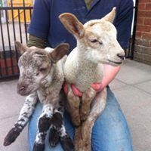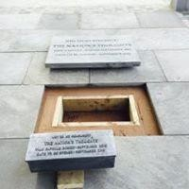

**Assessment and Record Keeping**

Key Workers are responsible for their Key Children’s progress, and for planning activities to move their learning on. They are skilled at analysing what each child is doing, identifying the progress made and identifying the child’s next steps. Photos and videos are uploaded onto a secure online portal called Tapestry. Upon enrolment at Stepping Stones, parents are given unique login details which enables them to access these photos and videos for their child. Parents are able to comment on the posts and add their own observations of what their child has done at home. This is a really important link between home and the setting. In the summer term, parents are invited to a parent consultation meeting with their child’s Key Worker. The purpose of these meetings is to discuss the progress, development and achievement of their child.

