NEWSLETTER
July 2026
DATES FOR YOUR DIARY 2026/2027
INSET DAY- Friday 3rd July
INSET DAY- Monday 20th July
Summer holiday- Friday 17th July – Monday 31st August
INSET DAY-Tuesday 1st September
Inset Day- Friday 23rd October
Inset Day- Monday 4th January 27
Inset Day- Sports Day- June TBC
Inset Day- Friday 2nd July 27
Bags 2 school- Wednesday 20th January 27

----------------------------------------------
This terms topics
This term, we are exploring the topic of Summer. Throughout the term, the children will take part in a range of fun and engaging activities linked to the season. We will be learning about summer weather, plants and animals, holidays, the seaside, and how people enjoy the warmer months. Our activities will include stories, arts and crafts, music, outdoor learning, and games to help develop the children's knowledge, creativity, and confidence while making the most of the season.
----------------------------------------------
EHO
We are happy to announce we gained a 5* rating.
----------------------------------------------
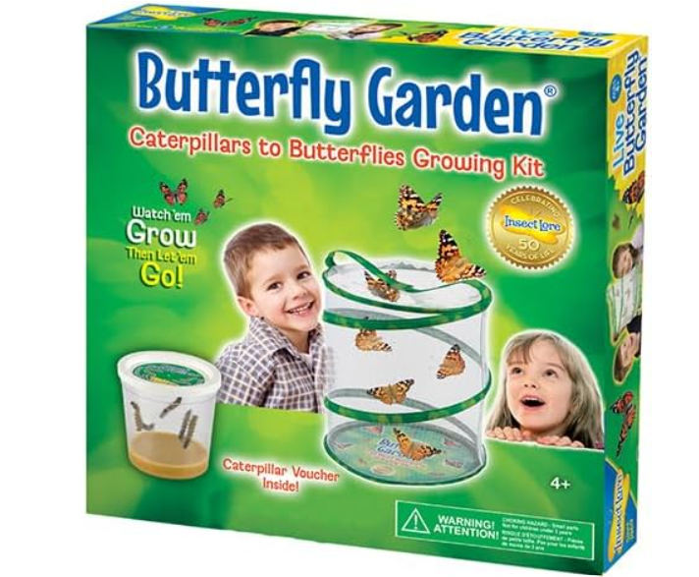
Growing Butterflies
Over the past few weeks, we have been growing our own butterflies as part of our Summer topic. The children have loved observing the amazing life cycle of a butterfly, watching the tiny caterpillars grow bigger each day before forming their chrysalises. We talked about each stage of the life cycle and learnt how caterpillars change into beautiful butterflies through a process called metamorphosis.

----------------------------------------------
Sports Day
We would like to say a huge thank you to everyone who helped make our Sports Day such a wonderful success. The children had a fantastic time taking part in all the activities and showed great enthusiasm, determination, and teamwork throughout the day.
Thank you to all the families for your generous donations and support. Your contributions are greatly appreciated and help us continue to provide exciting opportunities and resources for the children. We made a staggering £230.00. Thank you very much for your support.
----------------------------------------------
Parent Consultations
Parent consultations were a great success, we are going to do these twice yearly around November and May. But you are always welcome to arrange a chat with your child’s key persons or the manager if you would like.
----------------------------------------------
Big Thank You
We continue to be thankful for the lovely donations from our tree. It is very appreciated.
----------------------------------------------
ALREWAS SHOW
We are delighted to announce that we will be taking part in the Alrewas Show again this year on Saturday, 18th July. You will find us in a marquee show casing our setting.
----------------------------------------------
Cutting up Fruits and Vegetables
As per our lunch box guidelines, we kindly ask that all fruits and vegetables included in lunch boxes are cut into batons (long, thin sticks) and grapes and tomatoes cut into quarters.
----------------------------------------------

Other news
We’re delighted to have received a grant to fund new tablets from Alrewas Parish Council, as our current devices are now quite outdated. These new tablets will make it much easier for us to take photos and upload them to Tapestry, allowing parents to stay connected and see their children’s learning and experiences.
The devices will also be used to support the children’s development through carefully selected games and to provide access to music and other engaging resources.
----------------------------------------------
REMINDERS
We are a NO NUTS setting.
We make sure your child always has a water bottle, warm clothes for winter, a coat, change of shoes if necessary, a bag with a change of clothes, nappies (not pull ups unless actively potty training), wipes and cream if needed.
It is advised to have water in their bottle, but if you do have to give your child juice then please do not have it too strong.
If your child is toilet trained, please ensure they wear clothing that they can manage independently. We pride ourselves on encouraging independence and helping children develop self-help skills, including changing themselves. Items such as tights with dresses or very tight trousers can be tricky for children to manage on their own.
One of the highlights noted by OFSTED was how healthy our children’s lunchboxes are. We encourage all things healthy and have a routine where sandwiches are eaten first, followed by fruit or vegetables, and then a small treat. We also recommend choosing brown bread whenever possible, as it is higher in fibre and nutrients than white bread, helping children stay fuller for longer and supporting healthy digestion. About a year ago, we switched all our toast to brown bread, and all the children enjoy it.
----------------------------------------------
FUNDED EDUCATION FOR 3 and 4 YEAR OLDS
Parents must reconfirm eligibility every 3 months via their online account
https://www.staffordshire.gov.uk/Children-and-early-years/Childcare/Childcare-for-3-to-4-year-olds/3-4-year-olds.aspx
----------------------------------------------
Our Website
https://steppingstonesalrewas.co.uk/
----------------------------------------------
Joining Committee
We’re reaching out to invite you to be a part of something meaningful – join our committee at Stepping Stones.
Your voice, ideas, and involvement can make a real difference to our preschool community. Whether you can help a little or a lot, your contribution would be valuable and appreciated.
If this interests you, then please let us know.
----------------------------------------------
Parent Chat/Support
If you need to chat to any member of staff, your child’s key person or the manager, you can phone/email/arrange a meeting to discuss any of your queries. We do not want you to feel like you cannot ask us any questions. We are here to teach and support your children, and we love doing this!
----------------------------------------------
Policies and Procedures
We want to remind all parents and carers that if you are ever interested in viewing any of our policies and procedures, we are always happy to share them with you upon request.
Transparency and partnership with families are very important to us, and we’re more than happy to provide any information you’d like to see.
----------------------------------------------
Resources/Donations
If you or anybody you know works in a trade that can support us we would be truly grateful! We once had somebody work in ‘Partners’ and provided us with a bulk of paper, this was a great resource for us. We are always on the lookout for bags of play sand and everyday items.
Do you know of any big companies that would like to donate to a local charity?
If you would like to donate our details are
SteppingStones Pre School Play & Learn
090154 64250706

