NEWSLETTER
September 2026
DATES FOR YOUR DIARY 2026/2027
Inset Day- Friday 23rd October
October half term- Monday 26 October – Friday 30 October
Inset Day- Monday 4th January 2027
Bags 2 school- Wednesday 20th January 2027
February Half term- Monday 15 February – Friday 19 February
Easter term- Monday 29 March – Friday 9 April
May Day- Monday 3 May
May half term- Monday 31 May – Friday 4 June
Inset Day- Sports Day- June TBC
Inset Day- Friday 2nd July 2027
Break up for summer- Wednesday 21 July

WELCOME
A very warm welcome to all our familiar faces and new faces joining us at nursery!
It’s lovely to see our returning children back and settled, and we’re so excited to welcome our new children and families into our nursery family.
Here’s to a wonderful year filled with friendships, fun, laughter, learning and lots of special memories!
We can’t wait to see everyone grow, explore and thrive together.
----------------------------------------------
This terms topics
This term, we are exploring the topics ‘Out of this world’ and our youngsters are looking at ‘Colours’.
Throughout the term, the children will take part in a range of fun and engaging activities linked to the season. Our activities will include stories, arts and crafts, music, outdoor learning, and games to help develop the children's knowledge, creativity, and confidence.
----------------------------------------------
We have such a busy and exciting few months ahead at nursery, with lots of wonderful celebrations and special days for the children to enjoy!
Halloween – spooky fun, dressing up and lots of creative activities!
Harvest Festival – learning about harvest time, sharing and being thankful.
Diwali – exploring the Festival of Light through stories, crafts, music and activities.
Bonfire Night – learning about fireworks, staying safe and enjoying some colourful creative activities.
Remembrance Day – remembering and learning about the importance of peace and kindness.
----------------------------------------------

----------------------------------------------

----------------------------------------------
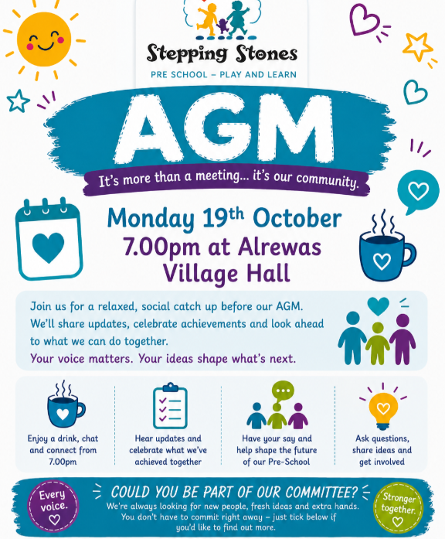
Our Website
https://steppingstonesalrewas.co.uk/
----------------------------------------------
Joining Committee
We’re reaching out to invite you to be a part of something meaningful – join our committee at Stepping Stones.
Your voice, ideas, and involvement can make a real difference to our preschool community. Whether you can help a little or a lot, your contribution would be valuable and appreciated.
If this interests you, then please let us know.
----------------------------------------------
Parent Chat/Support
If you need to chat to any member of staff, your child’s key person or the manager, you can phone/email/arrange a meeting to discuss any of your queries. We do not want you to feel like you cannot ask us any questions. We are here to teach and support your children, and we love doing this!
----------------------------------------------
Policies and Procedures
We want to remind all parents and carers that if you are ever interested in viewing any of our policies and procedures, we are always happy to share them with you upon request.
Transparency and partnership with families are very important to us, and we’re more than happy to provide any information you’d like to see.
----------------------------------------------
Resources/Donations
If you or anybody you know works in a trade that can support us we would be truly grateful! We once had somebody work in ‘Partners’ and provided us with a bulk of paper, this was a great resource for us. We are always on the lookout for bags of play sand and everyday items.
Do you know of any big companies that would like to donate to a local charity?
If you would like to donate our details are
SteppingStones Pre School Play & Learn
090154 64250706

